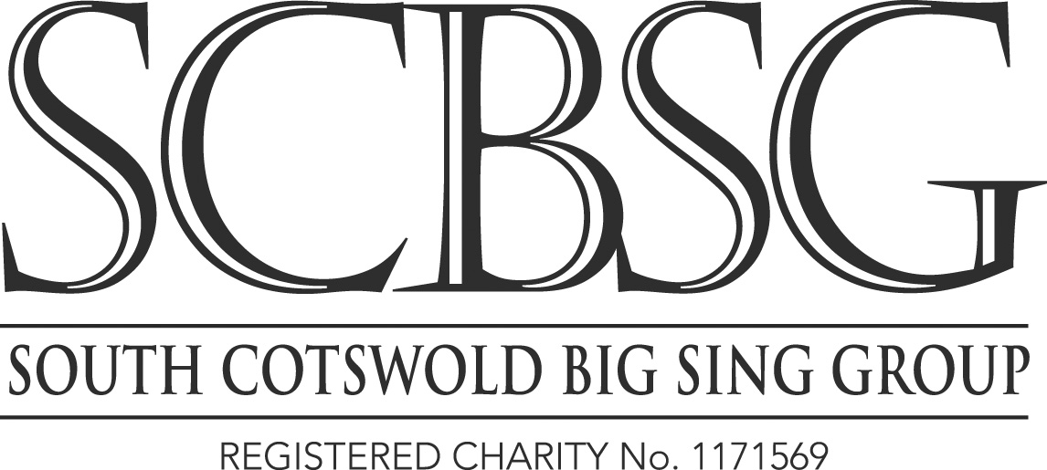
BERLIOZ TE DEUM WORKSHOP NEWSLETTER
Reply to Jos Gregson, 18 Willoughby Close,
Alveston,
Bristol BS35 3RW
Tel: 01454-411652
Email: jos@josgregson.plus.com
9th April 2023

Dear Singer,
We are looking forward to welcoming you to our Berlioz Te Deum Workshop at The Crypt School on April 22nd. This will be conducted by Adrian Partington and accompanied by Steven Kings.

TIMINGS
The timings are as follows:-
9.30am: Arrival and registration
10am -11am First rehearsal
11am -11.30 Coffee break
11.30am -1.00pm second rehearsal
1.00 - 2.00pm lunch break. PLEASE BRING A PACKED LUNCH.
2.00pm - 4.00pm third rehearsal.

SCORES
We have hired Schirmer scores from the Three Choirs Festival. They require these back so at the end please place them in the boxes provided as I do not want to have to chase them up. Adrian is using a Bärenreiter score but is also happy with Novello and Serenissima.
I will have Schirmer scores available for hire by any latecomers and also Serenissima scores available for sale. The latter are what we have used for both our last two concerts and are very good.

BUS
We will be running a bus from Thornbury to Gloucester and back on Workshop day. The bus will depart from outside Aldi in Thornbury at 8.45am and return from Gloucester at around 4.15pm after all the singers have returned to the bus. There are still places available.

CATERING
We will be serving tea, coffee and biscuits in the morning interval. Please help the environment by bringing your own mug, we will have recyclable cups and holders available in case you forget. Please bring a packed lunch.

PERFORMANCE
Adrian, Alison, our Vice-Chairman and I met with the new Head of Programming for the Cheltenham Music Festival, Michael Duffy and two members of his team in March. We had told them in June 2022 that we were proposing the Berlioz Te Deum as our main work for 2024 and this was the reason for holding this April Workshop.
Michael said that the Berlioz Te Deum did not fit in with his vision for the Festival and asked whether we would put on a major Holst work to celebrate the 150th Anniversary of his birth. After considerable discussion we reluctantly agreed and will be putting on a concert during the 2024 Cheltenham Music Festival featuring Holst’s Hymn of Jesus and the Poulenc Gloria.

We have booked Gloucester Cathedral on June 14th 2025 for a performance of the Berlioz Te Deum on our own behalf, the second work is still to be decided.

COMMITTEE
After many years as Concert Manager David Joyce would like to stand down. He will be kindly managing this workshop so we will be looking for a new Concert Manager after this event. If you either would like to volunteer yourself or can suggest someone please get in touch with myself or another member of the committee.

Rosemary Robinson would also like to stand down as Secretary. Rosemary has very kindly used her expertise to organise Zoom meetings which have been invaluable over the past few years. Again if you yourself would be prepared to stand as Secretary or can suggest someone please let me know.

I look forward to seeing you at check-in on the 22nd April.

Jos Gregson
Chairman, South Cotswold Big Sing Group

